ICS 4UI/4CI

Unit 4

Day 1

**Introduction to SDL**

There are several common methods of creating a graphical display. For 2D graphics, DirectX is the industry standard, but it is very complex. An easier alternative is SDL. For 3D graphics, OpenGL and DirectX are both popular libraries to use.

SDL is an event-driven programming model, which means nothing happens in SDL unless some external event such as keyboard presses or mouse movements force an action.

All visuals within SDL happen on a surface structure, which mimics the display that you see on the monitor. A surface is modified in the background and then flipped to be visible on the screen. The simplest program in SDL creates a surface, displays it, and then shuts down the program.

<< screen test >>

A more comprehensive program in SDL has an event loop. The event loop monitors all events that are happening inside the program. Any processing that the program needs to perform has to be within the constraints of the event loop.

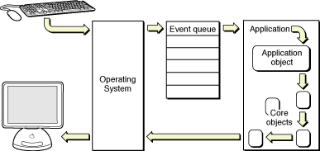

This means that any processing that the program needs to do must be broken up into chunks that are less than 1/60th of a second or the program will feel unresponsive to the user (frozen).

<< eventtest >>

<< event2test >>